Contents

Cargo Mobile App V 1. 0 Features 2

Home Page 2

Flight schedule 3

Flight schedule by route 4

Flight schedule details 5

Track cargo 6

Tracking detail and status 7

Book A charter 8

Cargo Mobile App V2.0 upcoming features for next week 9

Enquiry 9

Flight status 10

Charter requests 11

Recent cargo tracks 12

Products and service 13

Push notification 14

# Cargo Mobile App V 1. 0 Features

## Home Page

This is the page customer see at the first glance when opening the App . mainly contains all the availabe functionality that the app give. Track cargo, Flight schedule and book charter.

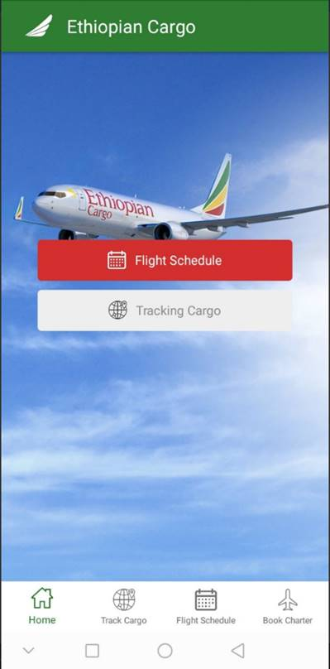

## Flight schedule

Want to see cargo flight schedule, just click on **flight schedule** button on the Center or just click on Flight Schedule at bottom. The schedule in here can show both for passenger and cargo based on customer interest.

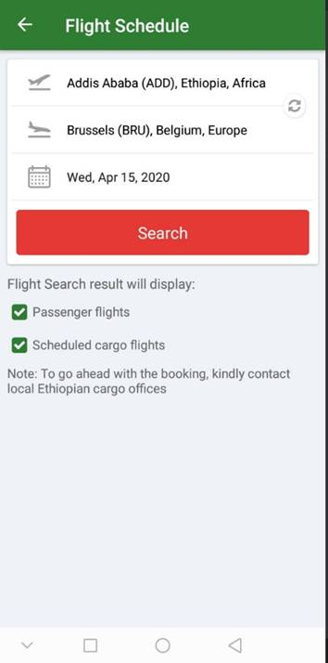

## Flight schedule by route

To get the flight schedule, enter the route information Departure and arrival airports and the date of travel. Below, there are two options that are left for customers these are passenger flight schedule and also for cargo. Entering the required information click on **search** button



## Flight schedule details

The schedule detail shows the flight availability for a day before, the requested and for next day i.e. yesterday, today and tomorrow. e.g. if the requested date is 30 May 2020. The result will show for 29 May, 30 May and 31 May.

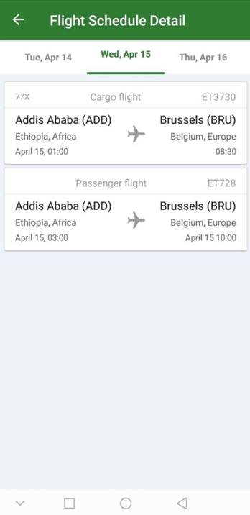

## Track cargo

In order to track cargo just click on ‘**Track Cargo’** button on the home page. to track the cargo shipment, there should be AWB number inserted on the box which says ‘**enter your AWB’** number and click ‘**Track’** button

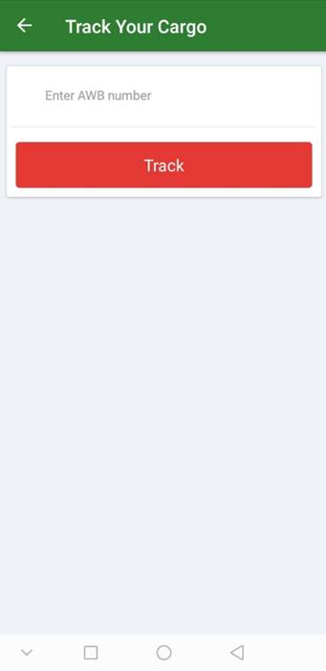

## Tracking detail and status

The shipment status will be displayed once the AWB number is inserted and track button is clicked. The detail shows the departure and arrival places, the piece/ weight, AWB number, and the overall status history date and time such as BKD, RCS, MAN etc.

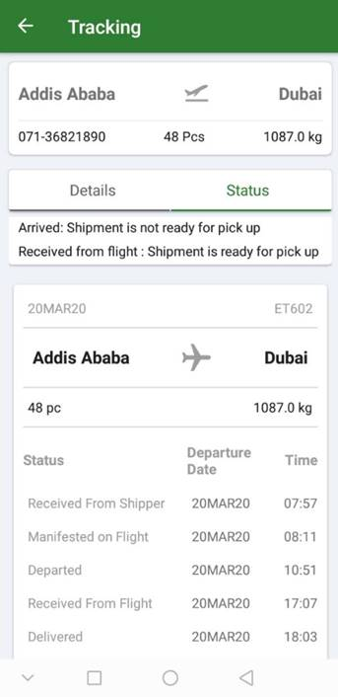

## Book A charter

In order to book a charter just click on the **book chart** icon on the bottom left side of the home screen. After doing this, the screen showed below will be displayed. Fill your personal and shipment / cargo details and click **submit request** button

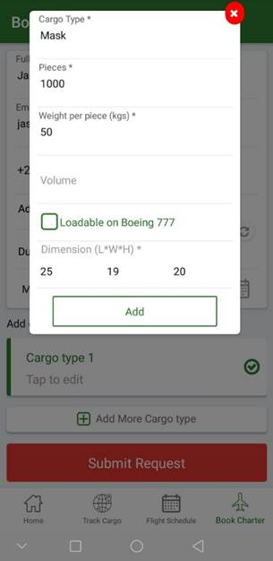 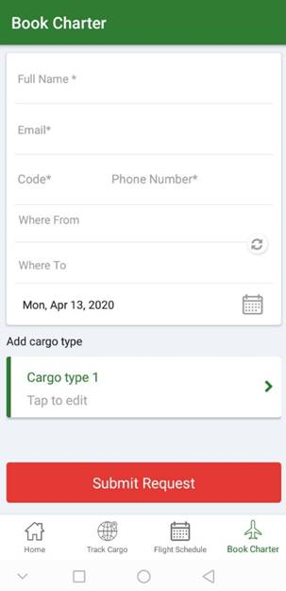

# Cargo Mobile App V2.0 upcoming features for next week

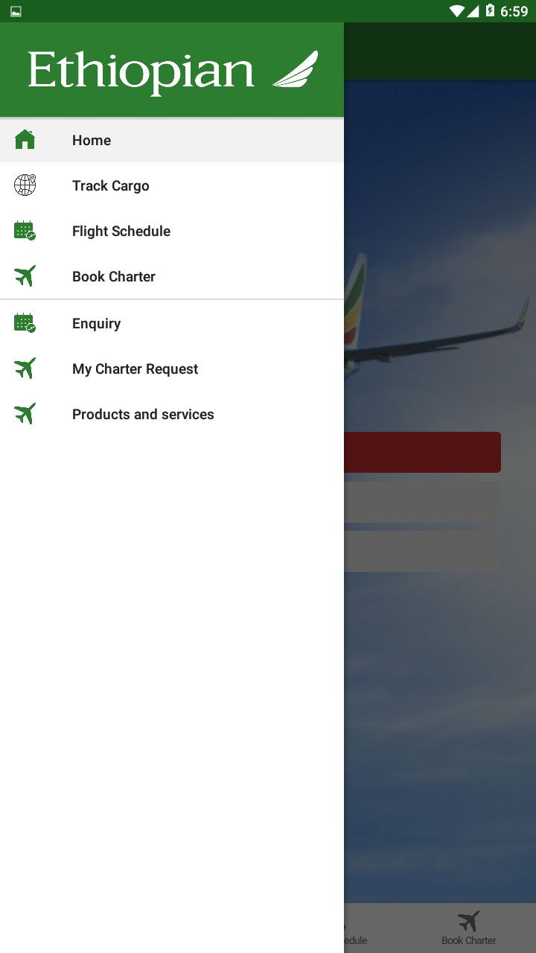

## Enquiry

Customers can send any enquiry regarding the service to cargo Teams. The enquiry can be received to cargo teams through their group mail address

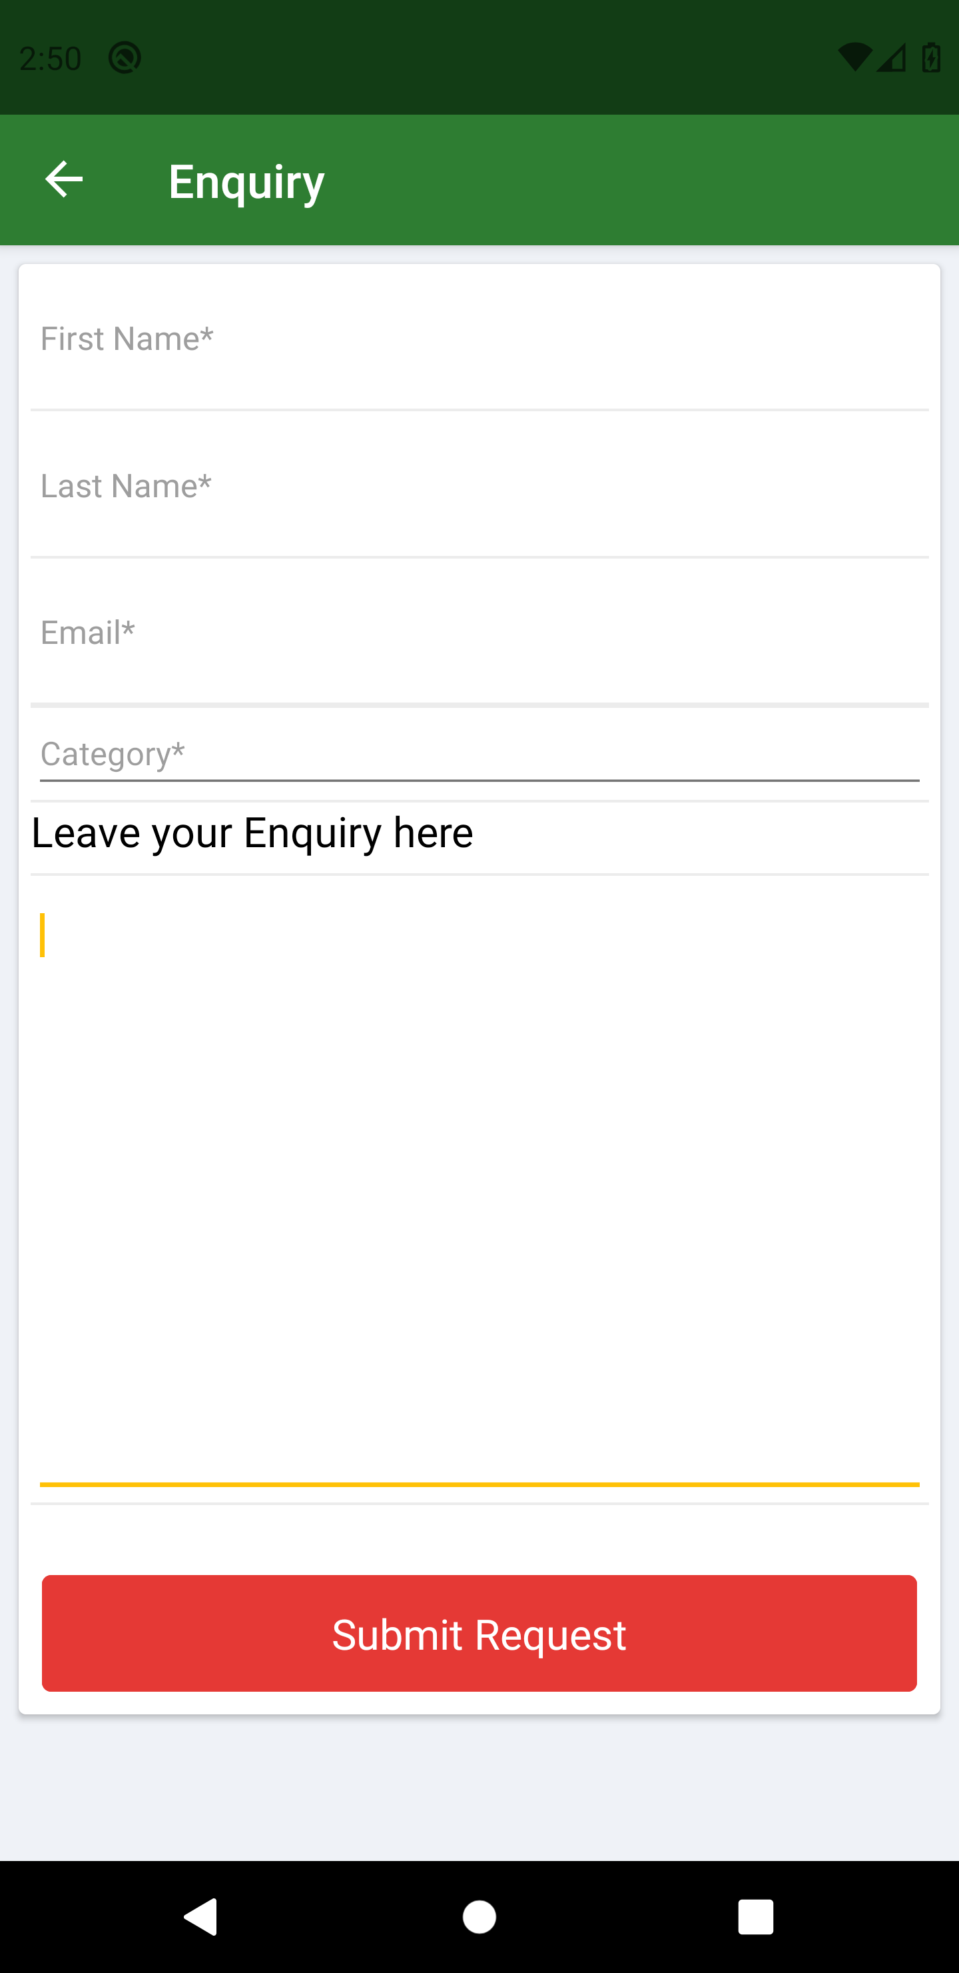

## Flight status

Customer can see the status for their cargo / charter flight status in the same way as it was used on flight schedule. The status can be seen using flight number and or route.

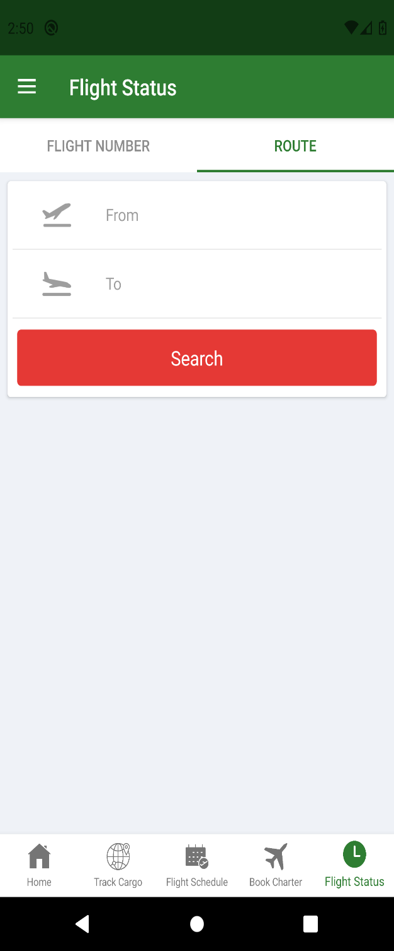

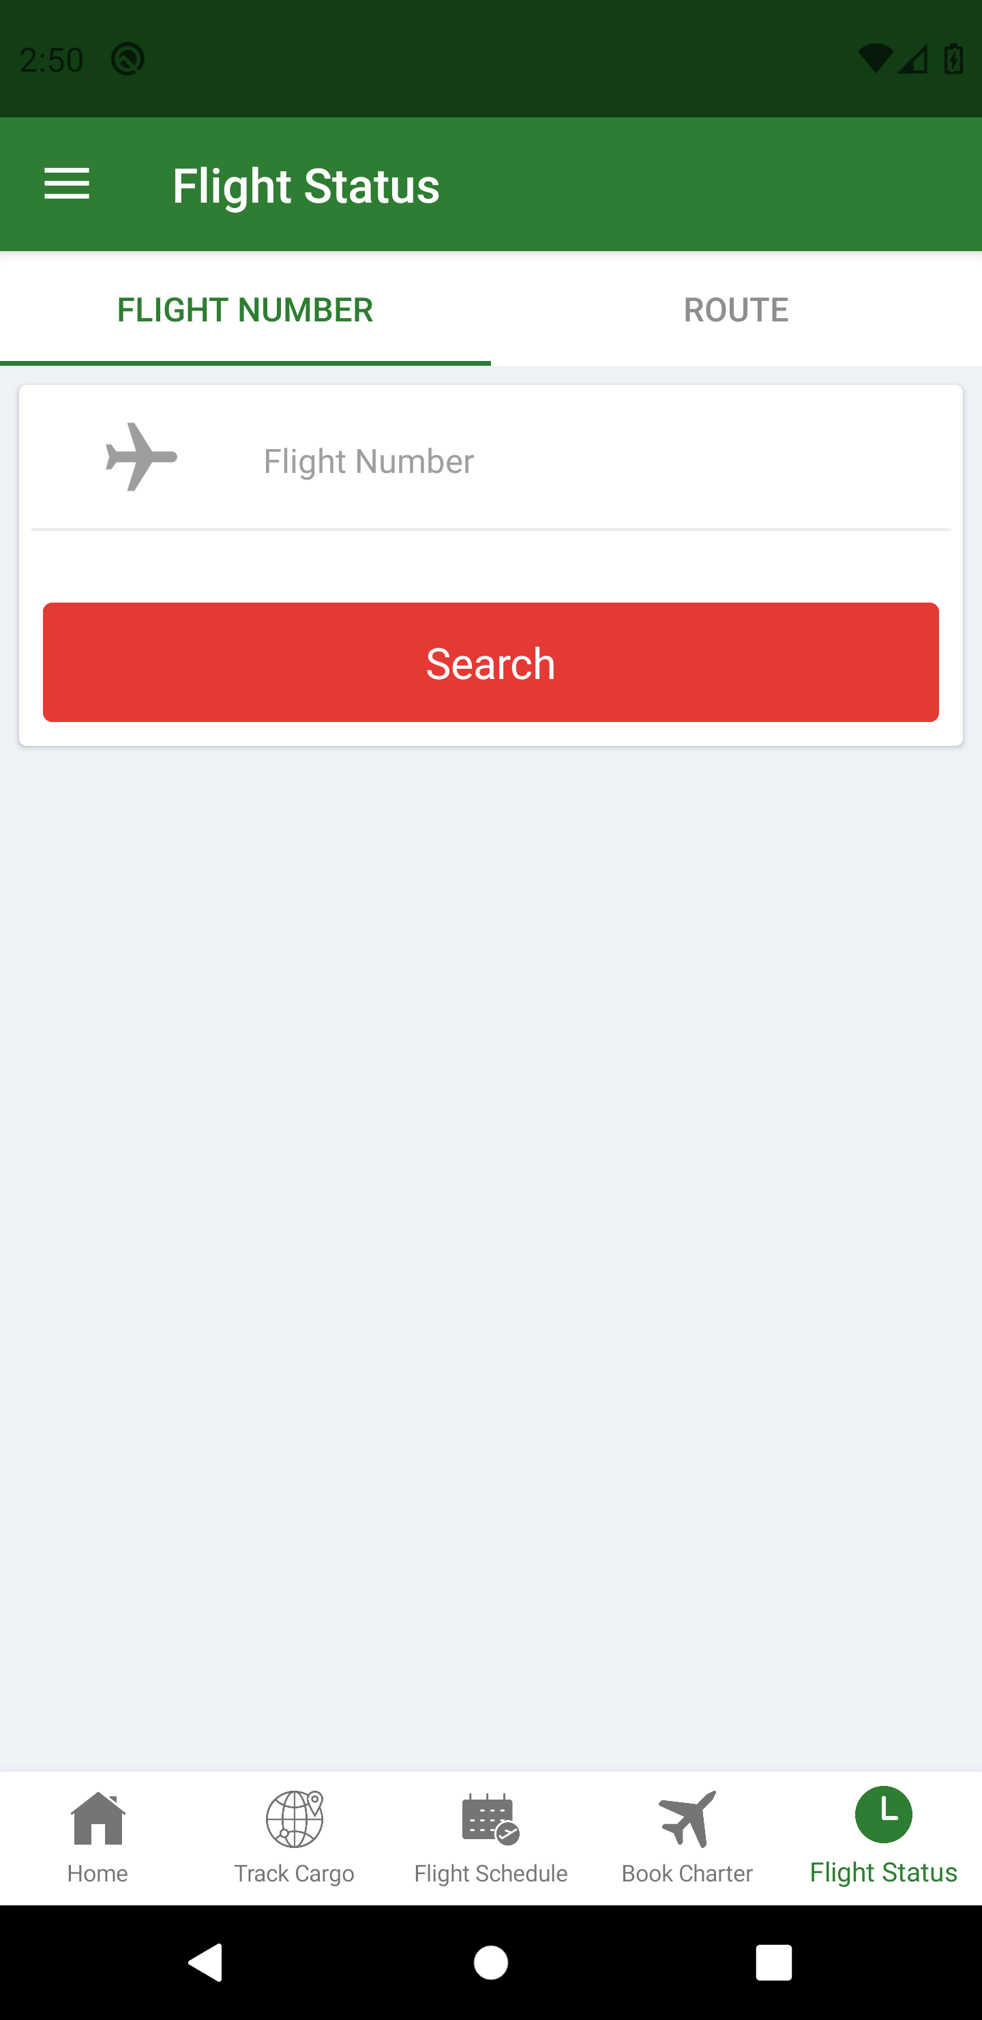

## Charter requests

the request that are made on the flight / cargo request are saved for customer to see the status

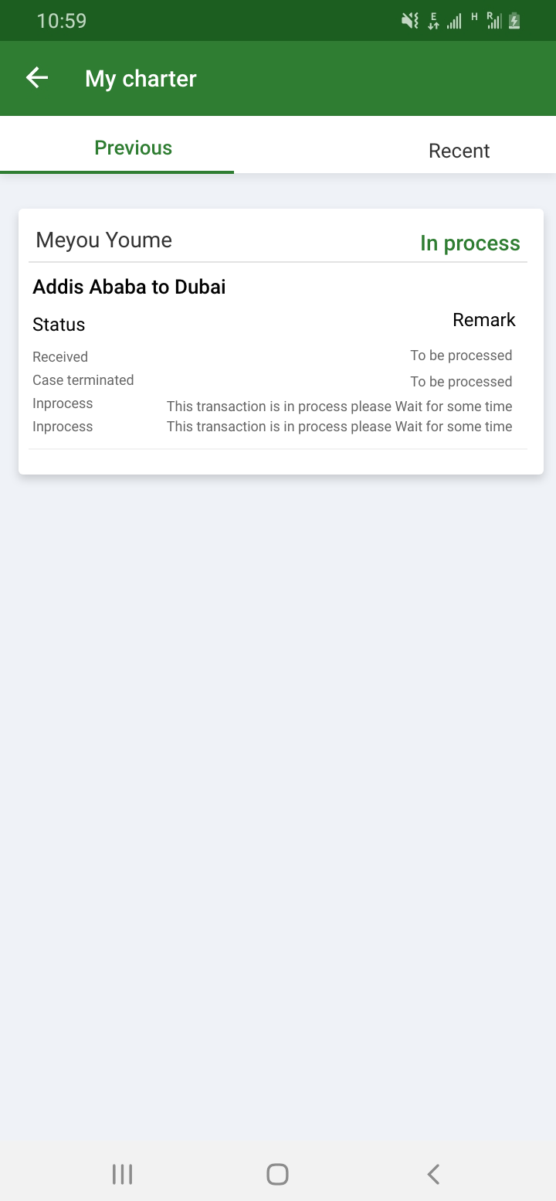

## Recent cargo tracks

Cargo shipment the are tracked once, the app will save the AWB and the status temporarily. This is to give comfort for customer not to enter AWB many times as they track the status

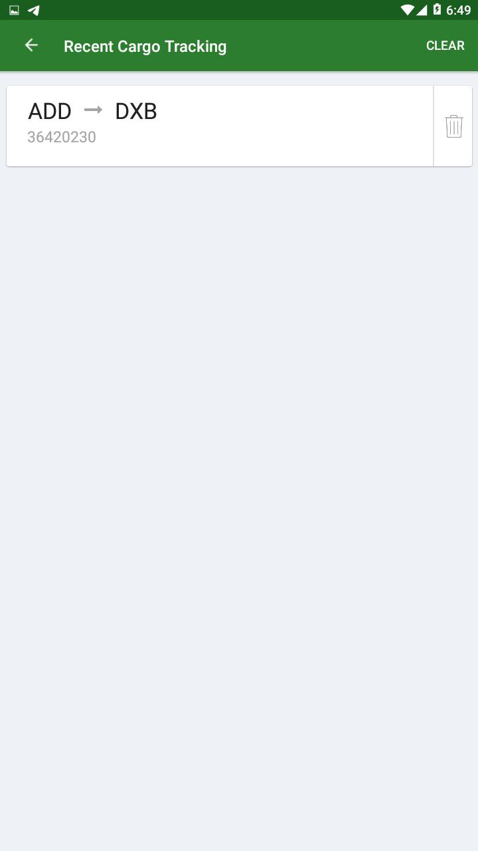

## Products and service

To brief the customer regarding the Services that cargo gives.

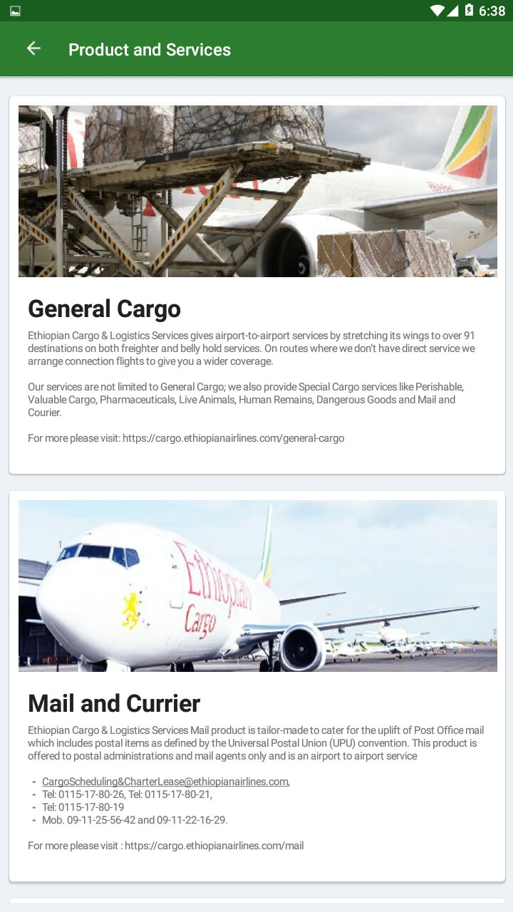

## Push notification

Send notification when shipment is ready

